1. INTRODUCTION
Changes can occur on almost every project and they often lead to delays and other negative impacts to the schedule and cost of a project. Large and complex engineering, procurement, and construction (EPC) projects are particularly susceptible to the negative impacts caused by changes. Changes can cause delay and disruption to engineering, procurement, fabrication, transportation and delivery, installation, and/or commissioning and startup activities. It is not unusual for an engineering change to cause a knock-on impact to successor procurement, fabrication, and installation work activities.
A change order or other impact can be modeled in a project CPM schedule using: 1) a group of added schedule activities, or fragnets; 2) adjustments to the durations of existing activities; 3) the insertion of lags or leads; and/or 4) imposed constraints. The overall objective of adding changes to a baseline or statused CPM schedule is to determine whether the overall completion date is improved, delayed, or remains the same as a result of the change. A well-known and widely utilized schedule delay analysis methodology is the Time Impact Analysis (TIA) or Update Impact Analysis (UIA), which is well suited for large and highly impacted projects and generally accepted as the preferred method to demonstrate a Contractor’s entitlement to a time extension or the Owner’s justification for receiving liquidated damages.
This article examines the various complexities in analyzing the schedule impact of multiple changes, with most examples drawn from a sample gas plant project. However, the topics that are discussed relate to a schedule delay analysis on any large, complex project. The sample gas plant project spanned several years and experienced approximately 16 months of delay and hundreds of alleged impacts. Retrospectively, the Owner had to determine a reasonable amount of time extension to grant an EPC Contractor due to 90 approved change orders. The authors utilized a TIA with multiple analysis windows¹ to assess the approved change order delays.
2. MANY EPC CONTRACTS REQUIRE IMPACTS TO BE INCORPORATED INTO THE SCHEDULE
Many EPC contracts require approved change orders and other impacts to be included in the CPM project execution schedules when these events occur. The main reason for a contemporaneous schedule impact analysis is to determine the magnitude of time impact, if any, that the change order or other type of impact would have on the overall remaining duration of the schedule.
Contracts often state that no adjustment to the critical milestone dates or the scheduled completion dates would be made unless the delay exceeds the float value of a critical path activity, as shown in a sample clause below:
The Critical Milestone Dates and Scheduled Completion Date shall be adjusted only when necessary to reflect any actual delay in the performance of a work activity in the critical path either occasioned by force majeure or for which COMPANY is responsible under this contract. The Critical Milestone Dates and Scheduled Completion Date shall not be adjusted for delay if the affected activity is not in the critical path and the duration of the delay does not exceed the activity’s total float as reflected in the latest reviewed Work schedule.
This concept is consistent with industry practice, as stated in the SCL Protocol:²
Unless there is express provision to the contrary in the contract, where there is remaining float in the programme at the time of an Employer Risk Event, an EOT [Extension of Time] should only be granted to the extent that the Employer Delay is predicted to reduce to below zero the total float on the activity paths affected by the Employer Delay.
AACE® International’s Recommended Practice No. 29R-03 Forensic Schedule Analysis also sets forth this requirement:³
In order for a claimant to be entitled to an extension of contract time for a delay event (and further to be considered compensable), the delay must affect the critical path. This is because before a party is entitled to time-related compensation for damages it must show that it was actually damaged. Because conventionally a contractor’s delay damages are a function of the overall duration of the project, there must be an increase in the duration of the project.
Thus, if the effect of adding any delays to the schedule is that float is consumed, but no actual delay to the completion of the project results from adding the delays, then the Contractor has no time extension entitlement.
3. TIME IMPACT ANALYSIS/UPDATE IMPACT ANALYSIS DEFINITIONS AND USES
The TIA/UIA is identified in numerous industry publications concerning the subject of delay analysis methodologies. The application of the TIA/UIA methodology has many variations.⁴ AACE® International’s Recommended Practice 29R-03 Forensic Schedule Analysis⁵ includes Method Implementation Protocol Modeled/Additive/Single Base (MIP 3.6) and Modeled/Additive/ Multiple Base (MIP 3.7). AACE® International generally defines the TIA/UIA as a modeled,⁶ prospective or retrospective CPM schedule delay analysis technique that adds Owner-caused and other excusable delays⁷ to the planned CPM schedule network.
Ideally, the Time Impact Analysis is calculated on schedules that are statused up through the day before each impact first occurred. A problem with statusing the schedule on the day before each impact occurred is that the analyst would need to accurately status each existing schedule activity on each day prior to the occurrence of each delay event, which would require the accurate determination of percent complete progress of each activity at the time that the delay occurred. Unfortunately, Contractors usually do not status work activities in their schedules at the time of each delay event, and the supporting activity progress data is typically performed only on monthly reporting cycles. Therefore, common industry practice is to insert the impacts into schedules that were updated prior to the occurrence of the impacts.⁸ Thus, the TIA/UIA is typically calculated by adding impacts that occur during each schedule period/window to the schedule which is statused at the start of each specific window or impact period (which is typically the same schedule that is statused at the end of the prior window), usually the the monthly schedule updates prepared during the project. While the TIA/UIA can be calculated using the entire period of the project as one as-planned schedule,⁹ the TIA/UIA can also be performed in windows or periods of time, where the statused schedule and its then current critical path can be analyzed separately for each window or period, and cumulatively for the project.¹⁰
Figure 1 illustrates conceptually the TIA/UIA methodology for a simple sequence of work.
Figure 1
Conceptual TIA/UIA Example
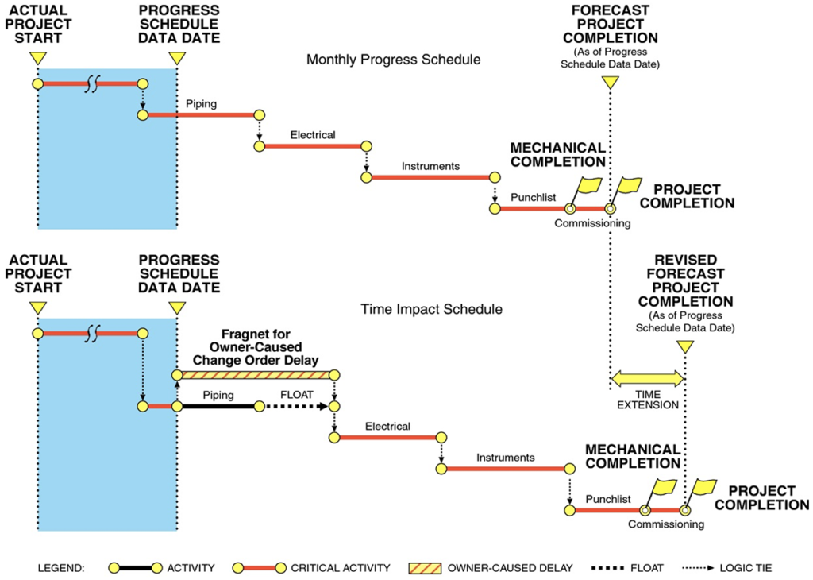
In Figure 1, a fragnet representing an Owner-caused change order is added at the time that the change order occurs to a statused or progress schedule update containing a simple chain of activities. After adding the fragnet for change order work, the critical path proceeds through the change order work, causing float on the original piping work activity, and extending the forecasted project completion date. The TIA/UIA is often applied to the baseline schedule or the schedule updates prepared contemporaneously during project execution.¹¹ Examining impacts between schedule updates is a “windows-based” analysis approach that one can use to evaluate the impacts to the project schedule, such as Contractor-caused impacts,¹² force majeure delays,¹³ delays as a result of changes (change orders) to the Contractor’s scope of work that were directed by the Owner, Owner-caused delays which may prevent the timely start of the Contractor’s planned schedule activities (start delays), or other delays caused by the Owner that may require additional time to perform its work (duration delays).
Typical reasons for inserting approved change orders and other impacts into the schedule include:
- Determining the impact on the critical path;
- Providing justification for a Contractor’s time extension;
- Providing relief from liquidated damages that may be assessed by the Owner if the Contractor’s completion date is later than the contractual completion date. The TIA/UIA can also be used to determine the date upon which the Owner is entitled to receive liquidated damages or actual delay damages if the actual project completion date, as defined by the contract, exceeds the project completion date resulting from the modeled schedule network with Owner-caused or other excusable delays inserted into the schedules. Any additional delay beyond the completion date calculated by the modeled schedule network with Owner-caused or other excusable delays inserted into the schedule would result from Contractor-caused problems;
- Potentially quantifying the amount of compensable delay;¹⁴ and
- Demonstrating potential schedule acceleration by comparing the statused, as-built schedules to the impacted schedules for each schedule window. Acceleration may be demonstrated if the forecasted completion dates at the end of a window, or the actual completion date at the end of a project, is earlier than the modeled impacted completion date with excusable delays inserted into the schedule.
3.1 THE TIA/UIA AND CONSIDERATION OF CONCURRENCY
It is not unusual for large and complex EPC projects to be impacted by a combination of Owner-caused and Contractor-caused issues. Depending on the timing of these impacts, the results of a TIA/UIA may provide the Contractor with entitlement for an extension of time. It is a common misconception in the construction industry that if the Contractor is entitled to an extension of time, then it is also automatically entitled to be compensated for the additional time that it has taken to complete the contract.¹⁵ It is not.
AACE® International’s Recommended Practice 29R-03 Forensic Schedule Analysis also acknowledges that an entitlement to an extension of time does not provide the Contractor with a right to delay compensation:¹⁶
Note that the terms, compensable, excusable and non-excusable, in current industry usage, are from the viewpoint of the contractor. That is, a delay that is deemed compensable is compensable to the contractor, but non-excusable to the owner. Conversely, a non-excusable delay is a compensable delay to the owner since it results in the collection of liquidated damages.¹⁷
A neutral perspective on the usage of the terms often aids understanding of the parity and symmetry of the concepts. Thus entitlement to compensability, whether it applies to the contractor or the owner, requires that the party seeking compensation show a lack of concurrency. But for entitlement to excusability without compensation, whether it applies to the contractor or the owner, it only requires that the party seeking excusability show that a delay by the other party impacted the critical path.
Based on the symmetry of the concept, one can say that entitlement to a time extension does not automatically entitle the contractor to delay compensation. In addition to showing that an owner-delay impacted the critical path, the contractor would have to show the absence of concurrent delays caused by a contractor-delay or a force majeure delay in order to be entitled to compensation. [Emphasis added.]
One can also say that the existence of concurrent contractor-delay does not automatically negate the contractor’s entitlement to a time extension. In fact, if a party is not seeking compensation for the delay, be it the contractor forgoing delay damages and seeking only a time extension, or the owner forgoing liquidated damages and only defending the contractor’s compensable delay claim, that party need not concern itself with its own concurrent delays.
This means that a single contractor-delay concurrent with many owner-delays would negate the contractor’s entitlement to delay compensation. Similarly, one owner-delay concurrent with many contractor-delays would negate the owner’s entitlement to delay compensation, including liquidated damages. While, in such extreme cases, the rule seems draconian, it is a symmetrical rule that applies to both the owner and the contractor and hence ultimately equitable. [Emphasis added.]
The Contractor also may have experienced simultaneous critical and near-critical path delays due to its own problems that also would have extended the project absent Owner-caused delays. In other words, an extension of time based on the application of a TIA due to Owner-caused delays should not automatically provide justification for compensable delay to be paid to the Contractor without consideration of concurrent Contractor-caused delays, unless otherwise stated in the Contract.
For example, an analyst may incorrectly conclude that the total time extension entitlement or total actual delay is compensable. This conclusion may be incorrect if the analyst fails to address concurrent delays in the as-built schedule,¹⁸ or if the time extension is longer than the actual delay that occurred as the result of acceleration or other delay mitigation.¹⁹
An additive delay analysis, such as the Time Impact Analysis, by itself does not provide an answer to the issue of compensable delay. If a Contractor incurs additional costs that are caused by both Owner delay and concurrent Contractor delay, then the Contractor should only recover compensation to the extent it is able to separately identify the additional costs caused by the Owner delay from those caused by the Contractor delay. If it would have incurred the additional costs in any event as a result of Contractor delays, the Contractor will not be entitled to recover those additional costs.²⁰
Therefore, the analyst should consider performing an As-Built But-For (ABBF) Schedule Analysis to quantify compensable delay and to address the issue of actual concurrent delay on the as-built schedule. The results of the TIA/UIA are often substantially different from the amount of Owner-caused delay determined from an ABBF Schedule Delay Analysis,²¹ which quantifies the Contractor’s entitlement to receive compensable delay by determining the earliest date that various completion activities could have been achieved but-for the Owner-caused compensable delays that occurred during the project. The ABBF Schedule Delay Analysis addresses concurrent delays, and the net period of Owner-caused delay may be compensable after concurrency of Contractor-caused and other excusable, noncompensable delays are addressed.²²
Therefore, to avoid an incorrect conclusion, a schedule impact analysis can be used to calculate the time extension to which the Contractor is entitled as a result of Owner-caused and other excusable delays and the basis for the Owner’s entitlement to liquidated or actual damages. The ABBF Schedule Delay Analysis can be used to determine the compensable delay days to which the Contractor is entitled to receive additional time-related costs as a result of Owner-caused delays.
3.2 ASSESSMENT OF POTENTIAL IMPACTS CONTAINED WITH DURATIONS AND LAGS
For many large and complex EPC projects, Owner-caused delays may be portrayed in the baseline schedule or subsequent schedule updates in the form of new activities or increased durations and lags associated with existing schedule activities. If the Owner’s scope changes or other Owner-caused delays affect the planned performance of existing schedule activities, these delays would normally be shown in the schedule updates in the form of extended activity durations (longer activity durations compared to the Contractor’s original planned activity durations), or extended lag durations²³ in the relationships between activities (longer lag durations compared to the Contractor’s original planned lag durations). For example, a start-to-start 0-day (SS 0) planned relationship lag may have been extended to a start-to-start 10 (SS 10) actual relationship lag that accounts for a delay caused by the Owner.
If, however, the Owner and Contractor agreed in the executed change orders that the new scope of work caused no delay to the project completion date, then the schedule updates may not contain any new activities representing the changed work or any extended durations or extended activity relationship lags. The absence in the schedule of delays associated with agreed change orders may also be consistent with the Contractor acknowledging that it included costs in the change order pricing to mitigate the effect of any potential delay that otherwise may have been caused by the change order. However, the absence of delays associated with agreed change orders in the schedule updates may simply be improper schedule management and updating by the Contractor.
Alternately, a change order may have increased the duration of an activity or the relationship time between activities. However, if such increased activity or lag durations did not affect critical path activities, then there would be no delay to the project completion date. This result would not entitle the Contractor to a time extension or additional time-related costs in the change order pricing. Delays caused by force majeure events may also be shown in the schedule updates in the form of extended activity durations or extended lag durations in the relationships between activities. Typically, Contractors are entitled to time extensions for force majeure delays but are not entitled to delay compensation unless stated otherwise in the contract.
Similarly, Contractor-caused delays may also be shown in the schedule in the form of extended activity durations or extended lag durations in the relationship between activities. It is common that Contractor-caused delays are not labeled as such, but instead can be determined by comparison of planned and actual durations of activities or planned and actual relationship lag durations.²⁴ Because the Contractor often controls the updating of the schedule, the cause of these delays may not be readily apparent. In particular, a Contractor will rarely identify delays for which it is responsible in the schedule as new activities.
4. DIFFICULTIES ENCOUNTERED IN HIGHLY IMPACTED, COMPLEX PROJECTS
Large and complex projects are challenging endeavors. The magnitude of these projects can range from hundreds of million dollars to several billion dollars in contract amount. Moreover, these types of projects will often span multiple years. Like any other project, large and complex projects will likely be affected by a multitude of changes, delays, and performance problems intertwined with varying degrees of root-cause responsibility by the Owner, EPC Contractor, force majeure events, or a combination of all three. When a large and complex project becomes highly impacted and disrupted, some difficulties encountered while trying to impact a CPM schedule for change orders include, but not limited to, the following:
- Thousands of schedule activities may be included within the CPM schedule, which could include hundreds of activities in progress for any given status date;
- Contractor-prepared CPM schedules may be deficient if they contain open-end activities, overuse of constraints, incorrect as-built dates, and inaccurate progress information;
- Multiple change order impacts may occur that are concurrent and extend over many months or years;
- The change order process often requires multiple Contractor submittals and Owner approvals before the changed work can be performed;
- Sufficient information is often not provided to describe how change order work impacted existing schedule activities;
- Numerous concurrent Contractor-caused impacts occur;
- Variable activity detail may exist in the schedule (e.g., many activities for smaller scopes of work and few activities for major scopes of work);
- As-built contemporaneous records are not at the same level of activity detail that is described in the CPM schedule;
- Sufficient data may not exist to accurately determine the actual progress of the existing work at any given time; and
- Information is not available regarding when the changed work was actually performed and how long it took to complete the changed work.
Resolution of these difficulties to enable a proper schedule delay analysis will most likely require significant time and costs. These issues should be examined in detail prior to starting a detailed TIA or any schedule analysis. Based on the difficulties listed above, it may be necessary to find alternate schedule impact analyses methods that can be performed cost effectively.
5. EXAMPLES OF IMPACTS CAUSED BY CHANGE ORDERS TO CONSIDER WHEN PERFORMING A TIA/UIA
For the sample gas project used for this article, the intent of the Time Impact Analysis method was to model the effects of the change orders by impacting existing schedule activities with the changes and estimate the impact on the overall project completion date, if any. Existing schedule activities, i.e., those that were included in the Contractor’s baseline schedule and subsequent schedule updates, that were found to be affected by the change order scope were impacted to show both how the timing of the change order events impacted the start or finish dates, and how the change order work added (or reduced) their durations. The most common impact format is the added fragnet activity or group of fragnet activities; however, other forms of change order impacts affected the schedule such as extended durations on existing schedule activities, an added constraint date to an existing schedule activity, a start delay to a successor activity, or a combination of all these types of impacts. A brief discussion of these various forms of impact is provided in the following sections.
5.1 FRAGNET DELAYS TO MODEL INCREASED DURATIONS OF EXISTING ACTIVITIES
Many added change orders caused an increase to the remaining duration of existing activities in progress at the time the change order scope was known. Many change orders included a scope increase for design changes that added engineering hours to design-related activities as well as increased scope for added quantities of material to be installed on subsequent and related construction activities. Figure 2 below provides a graphical explanation of how a fragnet duration impact is added to a statused schedule to model the effect of a duration delay to a work activity resulting in an extension of time.
In Figure 2, a change order impacted Activity A, Prepare Isometric Drawings, and Activity B, Install Piping. When the duration of the change order work is added to the duration of Activity A and Activity B, and the schedule file was recalculated with the added delays, the project completion was extended in time to a later date. Thus, the Contractor may be entitled to a time extension as a result of the added scope of work.
Figure 2
Example of Fragnet Delay to Model the Increased Duration of an Activity
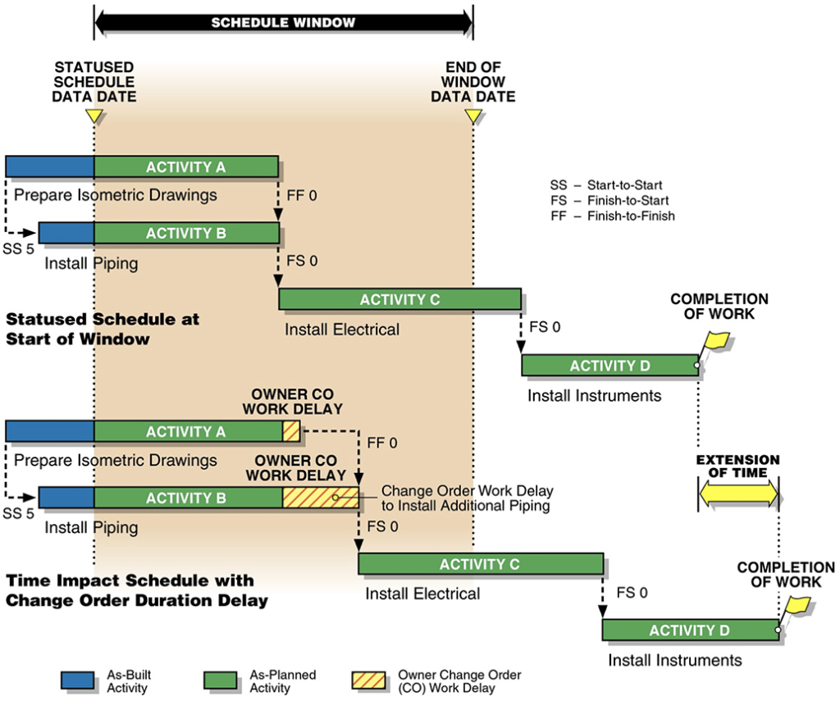
Sometimes an actual delay event cannot be identified, but delays can be quantified from the comparison of the planned and actual activity durations and relationship lag durations, as measured by the activity data at the end of the window and the planned activity durations and relationship lags at the beginning of the window. These duration and lag variances are then used to model the effect of the delays by inserting the quantified delays into the schedule that was statused at the start of the window, or to the schedule that is statused as of the day before the date when the delays actually occurred, depending on the accuracy of the schedule progress data.²⁵ Figure 3 provides a graphic explanation of how a fragnet associated with a Change Order is added to the statused schedule to model the effect of a 10-work day duration delay to Activity C that was quantified by a duration variance calculation.
Figure 3
Example of a Fragnet Delay
Quantified by a Duration Variance Calculation
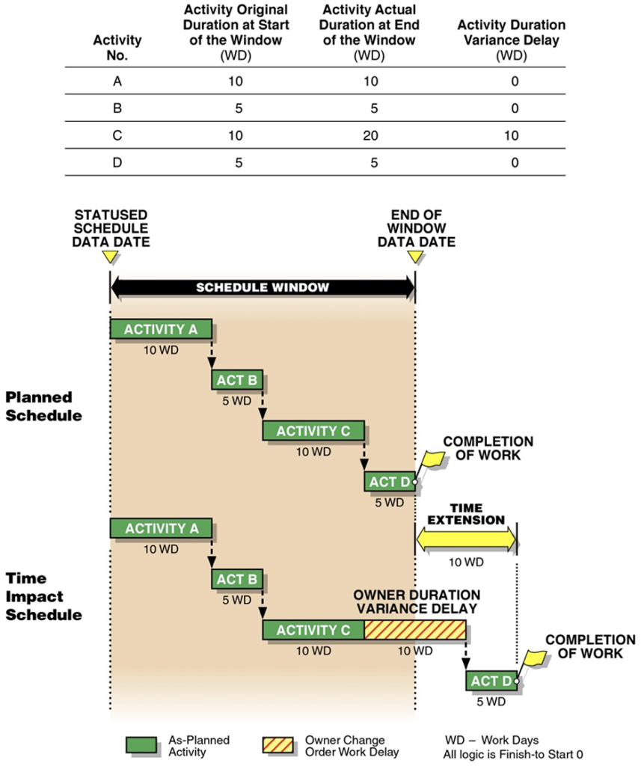
5.2 FRAGNET DELAYS THAT MODEL ADDED DURATIONS ON FUTURE WORK ACTIVITIES
In another Time Impact Analysis example, a change order impacted existing schedule activities that had not yet started but were identified to be affected during the time period covered by the analysis window. These impacts were quantified and added to the forecasted activities outside the analysis window when the change order scope was known. For example, if a change order is approved during the engineering phase (for example, analysis Window 1) that adds work to the construction of a piping system (in, for example, analysis Window 5), the increased activity duration is added to the affected future construction activity during the time of examination of the analysis window when the changed work was known or agreed. Figure 4 is a graphical explanation of how a fragnet (Owner Delay 2) is added to the statused schedule to model the effect of an extended duration delay to a future work activity that is to be performed in analysis Window 5, which is after analysis Window 1.
Analysis Window 1 was the period that the change order was identified, known, and agreed, and also caused delay to the engineering work (Delay 1) that was being performed in analysis Window 1. Additional construction work modeled as Delay 2 in Window 5 because the scope of the additional construction resulting from the change order was known during analysis Window 1. Therefore, it is appropriate to add both Delay 1 and Delay 2 when performing the analysis of the impact of the change order during analysis Window 1. In this case, the Contractor may be entitled to a time extension as a result of the engineering and construction work delays that were caused by the change order.
Figure 4
Example of Fragnet Delay Added to a Future Work Activity
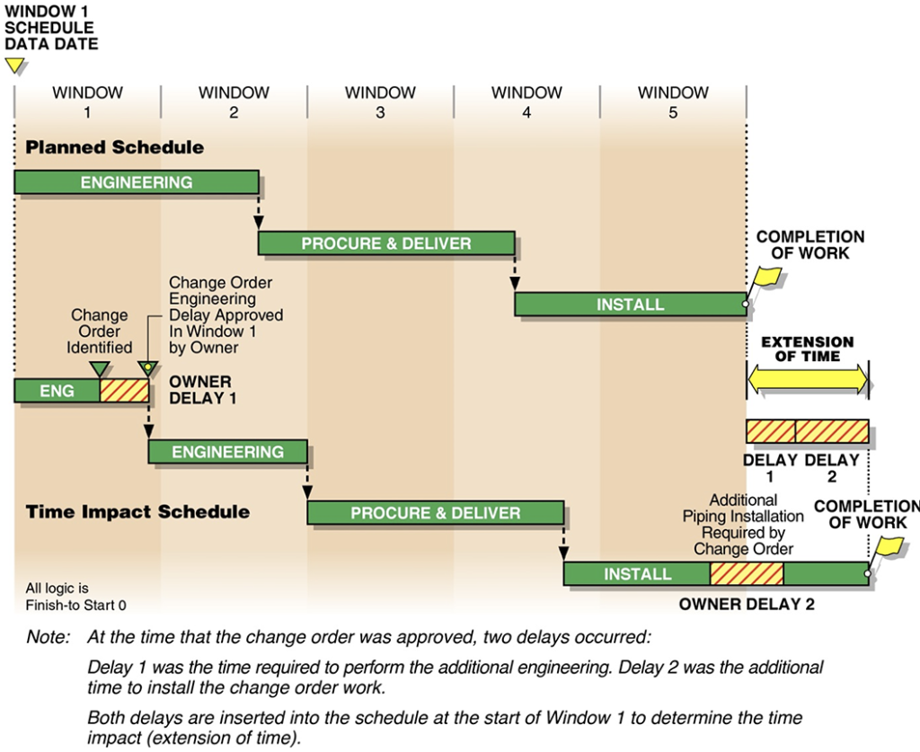
5.3 FRAGNET DELAYS THAT MODEL A START DELAY TO AN ACTIVITY
For a start delay impact, the project documentation is used to establish the duration of a start delay²⁶ that commenced before the start of an existing activity, such as may be the case when an Owner approval delay occurs. For example, an Owner may have taken an unreasonable amount of time, in excess of what was required by the contract documents, to approve a Contractor’s submittal package, which then delayed the start of a successor Contractor activity. These start delays can be modeled as an increase in the value of the start lag, or as a new activity representing the duration of the start delay. The modeled delay duration is added into the schedule at the time when the delay was first known to affect the time between activities.
Figure 5 provides a graphic explanation of how a fragnet is added to the statused schedule to model the effect of a start delay to a work Activity C that was to start 10 work days after the finish of predecessor Activity B.
Figure 5
Example of Fragnet Delay Added to Model a Start Delay to an Activity
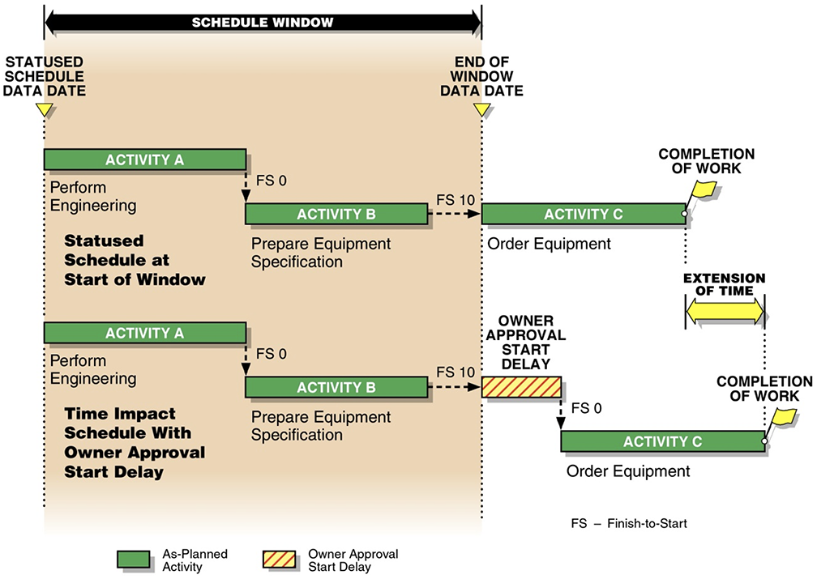
As depicted in Figure 5, a hypothetical Owner-caused delay in the approval of an equipment specification affected the start of the “Order Equipment” Activity C, causing a delay to the completion of the work associated with that part of the schedule. In this case, the Contractor may be entitled to a time extension as a result of the Owner approval delay. Similarly, other types of relationship delays can be added to the schedule to model the effect of finish-to-finish (FF) or start-to-finish (SF) relationship delays.
5.4 FRAGNET DELAYS THAT MERELY CONSUME FLOAT
The concept of a delay added to a statused schedule, where the result is the consumption of available float but no delay to the Completion of Work date, is illustrated by Figure 6. In this example, 7 work days of float exists on Activity 4 in a baseline CPM schedule, and a 3-work day delay to Activity 4 decreases the available float for that activity, in this case from 7-work days float to 4-work days float, but does not delay the Completion of Work.
Figure 6
Example of a Fragnet Delay
Whose Effect Is Merely to Consume Available Float
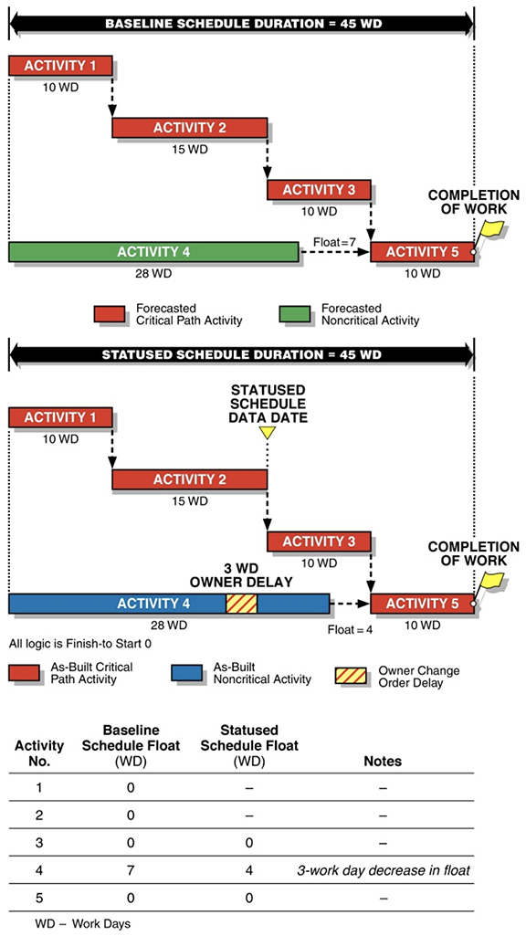
5.5 CONTRACTOR-CAUSED DELAYS BEYOND TIME EXTENSION ENTITLEMENT
A comparison of the Critical Milestone dates and Project Completion date in each impacted schedule can also be made to the Critical Milestone dates or Project Completion date determined by the actual status of the work at the end of the each schedule window. The projected Critical Milestone dates or Project Completion date in the statused schedule at the end of certain windows may be later than the impacted Critical Milestone dates or Project Completion date modeled by the inserting Owner-caused delays into the statused schedule. This comparison determines the amount of Contractor-caused delay remaining in the statused schedule at the end of the window, a result which would indicate additional actual delay that was caused by the Contractor.
Figure 7 illustrates this concept. In this example, a 2-work day Owner-caused start delay during the window created a 2-work day time extension entitlement to project completion. Therefore, the Owner-caused delay to the 24-work day planned duration would result in a 26-work day duration in the time impact schedule. However, during the window, the Contractor actually required 5 work days to complete Activity A instead of the 3 work days that were planned, and 8 work days to complete Activity C instead of the 5 work days that were planned. Therefore, the Contractor delayed the project by an additional 5 work days beyond the 2-work day time extension entitlement resulting from the Owner-caused delay.
Figure 7
Additional Delay Caused by Contractor
Beyond Time Extension Entitlement
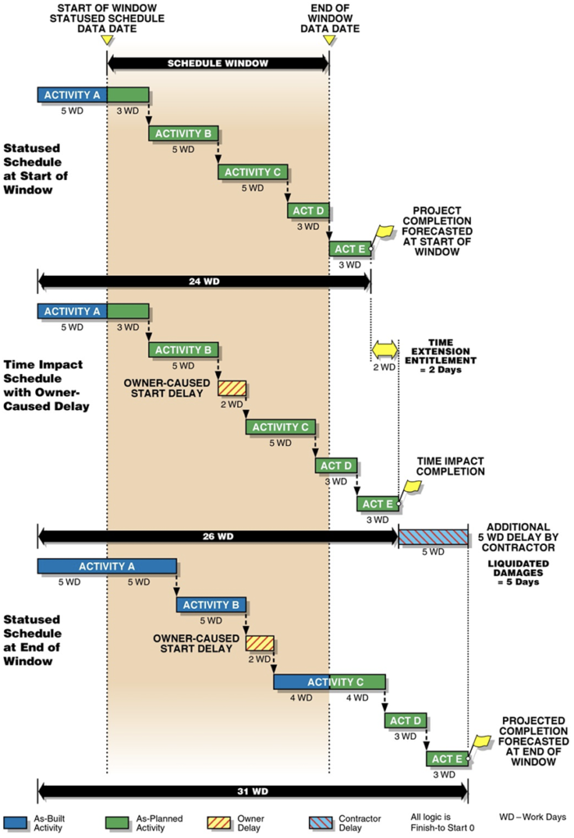
5.6 USE OF THE TIA/UIA TO ESTABLISH ACCELERATION
The TIA/UIA also is used to establish whether acceleration²⁷ may have occurred by comparing the dates for work activities in the Time Impact Schedule²⁸ to the dates for those same work activities in the As-Built Schedule, as shown in Figure 8.²⁹
Figure 8
Potential Proof of Acceleration
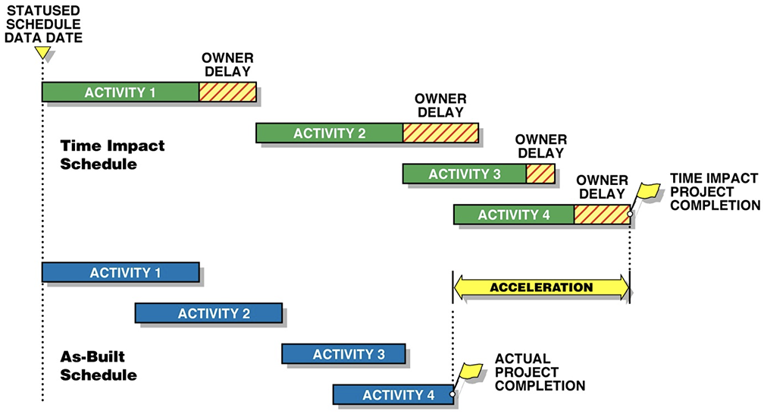
If the dates in the as-built schedule are earlier than the dates in the TIA/UIA Schedule, then the Contractor may have accelerated the work and incurred increased costs, or the Contractor may have performed a work around or resequence of its work³⁰ without incurring any acceleration costs. The Contractor may have accelerated its work, even if the activity dates are not earlier than the impacted schedule would indicate, by demonstrating that it supplied additional engineering resources or labor work crews to an activity or a group of activities to enable the Contractor (or its subcontractors) to perform the work sooner than it would have had it not provided additional engineering resources or labor work crews. However, if the Contractor is also responsible for delays to the project schedule, or if the Contractor’s planned manpower is lower than it should have been as a result of an underbid or bid error, then the Contractor may not be entitled to recover all of its acceleration costs. A separate analysis of the Contractor’s man-hour records that are related to the alleged accelerated schedule activities is then needed to determine if acceleration costs were actually incurred for these specific activities.
6. STEPS TO CONSIDER WHILE PERFORMING A TIA/UIA
While performing a TIA/UIA, it is important to determine the impact type and format, as described above, to more accurately model and quantify all impacts potentially affecting the schedule. In consideration of the previous examples, the methodology for assessing schedule impacts to the sample gas project, due to approved change orders, generally included the following eight (8) basic steps discussed in the subsequent sections.
6.1 STEP 1 – CREATE FRAGNET ACTIVITIES FOR CHANGE ORDERS
Fragnets, or sequences of new activities, were defined and created to represent each of the 90 change orders that were analyzed on the sample project. The supporting data needed for change order fragnet activity development were obtained from the individual change order files collected and recorded contemporaneously during project execution. These new fragnet activities modeled the change order process, which typically comprised the identification of the changed work through the formal change order issuance or execution. Specifically, the fragnets captured at least the following information: 1) the scope definition period; 2) the change request issuance; 3) the Contractor’s proposal period and issuance; 4) the change negotiation period; and 5) the change order signing by the Owner and Contractor, upon which work could commence (per the Contract).
It is not atypical for change order work to begin before the fully approved change order documentation is complete. In fact, for this sample gas project, the Contractor and Owner indeed both recognized that it was more important to start performing change order work as quickly as practical to keep pace with the current cadence of the work being performed and not wait for final signatures, although this was a deviation from a strict compliance with the Contract. Therefore, detailed research of the project records was necessary to fully understand when change order work actually commenced.
The fragnets also included activities related to the Contractor’s start of change order work when it differed from the formal execution of the change order. For example, if the Contractor started the work associated with a change order before the change order was approved, the analyst concluded that the fragnet should be inserted into the schedule to model the real effect of the scope change on the scheduled work and not inserted at the time of the later approval of the change order. Inserting the fragnet at the change order approval date, even though the work was started and potentially even finished earlier than the change order approval date, would incorrectly model the effect of the change order. Waiting for formal change order approval may not have been recognized as a delay by the Owner or the Contractor if the work proceeded without waiting for the change order approval.
This concept is illustrated by Figure 9 below. Because the change order work was performed before the change order was approved, the appropriate schedule impact model would be to insert the change order fragnets representing the engineering delay and installation of change order work delay into the schedule when that additional work was actually performed rather than after the change order approval date.
Figure 9
Example of a Fragnet Delay Where the Change Order Work Was Performed
Before the Change Order Approval Date
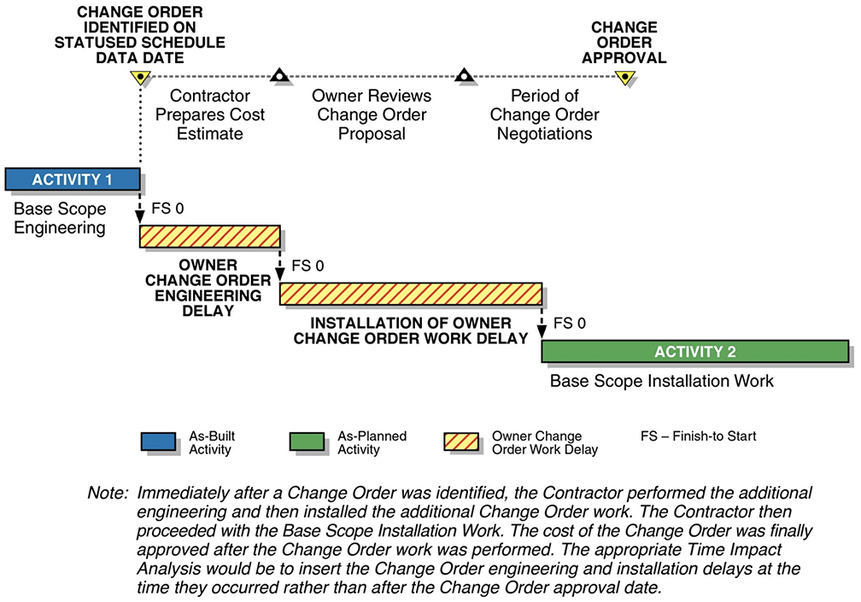
By adding the Owner-caused delays to affected schedule activities in the baseline schedule, or to subsequent schedule updates during which the work was delayed, or to future activities that are known to be affected by a change order when the delay caused by that change order is evaluated, the calculated schedule impact result determines the amount of time extension that would be required, if any, as a result of the Owner-caused delays to the then critical path of the project schedule.
6.2 STEP 2 – CONSIDER BLINDSIGHT APPROACH FOR FRAGNETS THAT SPAN MULTIPLE MONTHS
The schedule analysis was performed retrospectively and, therefore, the actual start and finish dates of the events were known. It was also known that the resolution and authorization of many changes, even relatively minor ones, spanned months or sometimes more than a year. Because the insertion of very long fragnets based on as-built dates could artificially skew the TIA/UIA and results, the blindsight approach was used.³¹ Using the blindsight approach, the analyst estimates the impact that the Contractor would have reasonably anticipated at a given point in time, which in this case is at the start of a given window when the scope of the change order work was known. Figure 10 shows an example of the blindsight approach when applied to a change order spanning multiple analysis windows.
Figure 10
Example Fragnet in Two Different Windows
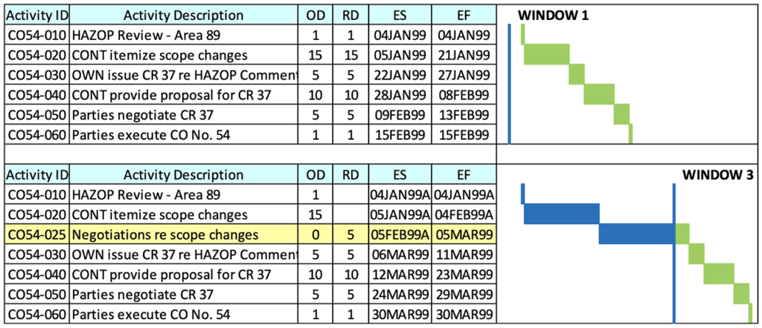
In Window 1, a potential change is introduced on January 4, 1999. Given the events that the Contractor knew it would have to undertake to receive formal approval to start the work, and given reasonable durations of those events (some of which were prescribed by Contract), the Contractor could have reasonably anticipated that work could commence on February 15, 1999, i.e., after the change order was approved.
However, approximately two months later, at the start of Window 3, the process had not progressed as originally anticipated. The Contractor took longer to itemize the scope changes (Activity ID CO54-020) and then the Owner disputed the Contractor’s list of scope changes (Activity ID CO54-025), neither of which could have been anticipated at the start of Window 1. Delays to these two fragnet activities delayed the forecasted start of the change order work to March 30, 1999.
One benefit of using the blindsight approach is that potential delays are introduced incrementally into the schedule. In Window 1, the potential impacts to existing work would be driven by the February 15, 1999 date; in Window 2, the impacts would be driven by a later fragnet completion date; and in Window 3, the impacts would be driven by the March 30, 1999 fragnet completion date. If these fragnet activities ultimately spanned six months, the incremental delays would be assessed in conjunction with (incremental) impacts from other changes.
Regarding fragnet activities, the actual durations obtained from researching the contemporaneous project records were used for the planned fragnet durations if these actual durations appeared reasonable, and one that the Contractor would have likely anticipated.
6.3 STEP 3 – ASSESS START OF WORK IMPACTS
Based on a thorough review of the change order information, the analyst found that one or more of the fragnet activities (described in Step 2) in each change order were the driving start of work event, whose completion date, or start of change order work date, was the same as the Contractor’s actual start of the change order work. These start of work events acted as the linkage between the change order fragnet activities and the impacted existing schedule activities.
Given the parties’ actions, and their apparent understanding that certain change order work would precede the Owner’s formal Change Order issuance, the use of fragnet start of work events were consistent with when the Contractor actually started work according to the contemporaneous project records. Based on the fragnet start of work event dates, fragnet activities for a given change order were inserted into the schedule update closest to the start of the impact of the changed conditions, which is consistent with the guidelines identified in AACE® International’s Recommended Practice 29R-03.³²
6.4 STEP 4 – ESTIMATE DURATION IMPACTS ON EXISTING SCHEDULE ACTIVITIES
The estimated additional (or reduced) engineering hours and field installation hours related to each change order were analyzed to estimate the extended or reduced impact on each activity’s duration. All change order engineering hours and field installation labor hours were contained within the supporting change order files that were maintained within the project records. Further, the change order hours were available by plant location, engineering discipline, and field installation discipline (i.e., civil, piping, instrumentation, electrical, etc.), which allowed for a reasonable assessment of estimated schedule activity duration changes by discipline and plant area.
The magnitude of duration impacts from change orders on existing schedule activities were assessed and estimated by comparing the engineering hours and field installation labor hours that were required to perform the change order scope of work against the Contractor’s planned engineering hours and field installation labor hours included for similar activities in the Contractor’s baseline schedule. This comparison was performed at the schedule activity level, such that the magnitude of the change order work could be applied against a specific existing similar activity to estimate the extended duration of that activity.
The start of work impacts discussed in Step 3 acted as the linkage between the change order fragnet activities and the impacted existing schedule activities. Furthermore, the fragnet start of work dates also were used as the initiating date for adjusting existing activity durations, which would model the additional (or reduced) work performed by the Contractor in relation to a change order. To determine the extended (or reduced) activity durations that were caused by a given change order, the following tasks were performed:
- Exported existing schedule activity data, including the budgeted engineering hours and field installation labor hours from the Contractor’s baseline schedule.
- Grouped the impacted schedule activity by discipline (i.e., civil, piping, instrumentation, electrical, etc.) and plant area, if the change order impacted more than one area.
- For each activity grouping, calculated the percentage of budgeted hours related to each activity, based on upon total budgeted hours.
- Applied the additional (or reduced) change order hours to the like activity grouping, and allocated hours to each activity based upon the percentages established in Item 3 above.
- Estimated the extended (or reduced) activity durations, using the change order hours that were allocated to each activity divided by the planned daily hours per work for each activity from the Contractor’s baseline schedule.
For example, Change Order No. 124 (Area 95 HAZOP Comments) added 2,674 field installation labor hours for both pipe fabrication and pipe erection based on the project records available for this change. Two Area 95 piping activities were found to be impacted by this change order, which are identified in Table 1:
Table 1
Piping Duration Changes Due to Change Order No. 124
Activity ID | Activity Description | OD (wds) | Budgeted MHs | MHs/ wd | % of Budget MHs | Change Order MHs | Changed Duration (wds)
R4F400RZ1 | A/G piping fabrication for Area 95 | 48 | 29,056 | 605 | 48% | 1,273 | 2
R4F400RZ2 | A/G piping Erection for Area 95 | 90 | 31,962 | 355 | 52% | 1,401 | 4
 | Totals |  | 61,017 |  | 100% | 2,674
The budgeted man-hours for the two impacted activities totaled 61,017, with 48 percent of the total man-hours related to piping fabrication and 52 percent related to piping erection. Using the 48:52 ratio between piping fabrication and piping erection in the Contractor’s baseline schedule, the 2,674 additional piping man-hours related to Change Order No. 124 were distributed, with 1,273 additional man-hours (48 percent) allocated to piping fabrication and 1,401 man-hours (52 percent) allocated to piping erection. The extended durations associated with Change Order No. 124 were then estimated using the planned daily man-hour expenditures of 605 hours per work day (29,056 budgeted hours divided by the original duration of 48 work days) for the pipe fabrication activity and 355 hours per day (31,962 budgeted hours divided by the original duration of 90 work days) for the pipe erection activity.
The estimated pipe fabrication change duration was estimated at two (2) work days (1,273 added hours divided by 605 planned hours per work day) and the pipe erection change duration was estimated at four (4) work days (1,401 added change order hours divided by 355 planned hours per day) due Change Order No. 124. Further, an assumption was used on the basis that the change order work would have been performed in similar ratios to the Contractor’s planned work due to the lack of available Contractor records that would provide the actual ratios. It was concluded that this allocation method was reasonable and a fair representation of the impact caused by Change Order No. 124 on these existing activities.
6.5 STEP 5 – DETERMINE THE USE OF FINISH-TO-FINISH LOGIC AND LAG VALUES
In review of papers, articles, and books for the Time Impact Analysis, the fragnet logic ties to existing schedule activities are usually represented with a single finish-to-start (FS) relationship. When tying the fragnet to existing activities, the relationships between the impacting events (fragnets) and the existing schedule activities are seldom that simple because the affected activities may have already started and are not yet completed; therefore, a FS tie will not accurately depict the impact on the schedule. In addition, a fragnet impact could affect numerous schedule activities in progress at the time that the fragnet impact was known.
A finish-to-finish (FF) relationship is a schedule logic tie that correlates the finish of one activity to the finish of a subsequent activity. If, for example, a FF tie with a ten-day lag (FF 10) was created between Activity A and Activity B, the FF tie would hold out the completion of Activity B by ten days after the Activity A was completed. Many of the change order impacts identified in the sample gas plant project impacted design, procurement, delivery, and installation activities that were in progress at the time when the change was recognized by the parties.
In these situations, the most appropriate logic tie from the fragnet to the existing activity in progress was determined to be an FF tie between the start of work event dates within the fragnet chain to the finish of the impacted existing activities. For those existing activities where the fragnet impact did not adjust the work scope or the scope of work from the fragnet change had not yet been defined, a FF 0 link between the fragnet and the finish of the affected existing activity was used. This FF 0 link ensured that the finish of existing schedule activities affected by the fragnet change could not be completed before the change has been resolved.
After the scope of work for the change was defined and the duration changes for the directly impacted schedule activities were estimated, a FF logic tie with a lag value equal to the estimated extended duration from the driving fragnet activity to the finish of the existing schedule activity was utilized. This logic ensures that the finish of the existing schedule activity would be delayed by at least the amount of the estimated extended duration of the work caused by the change order.
After the change order scope was established, the use of a FF logic link with a lag value was a reasonable and fair representation of the impact caused by a change order. For example, Table 2 is summary of an added fragnet chain of activities for an example Change Order CO44 that affected the finish of several existing HAZOP schedule activities.
Table 2
Fragnet and Impacted Existing Activities Due to Change Order No. CO44
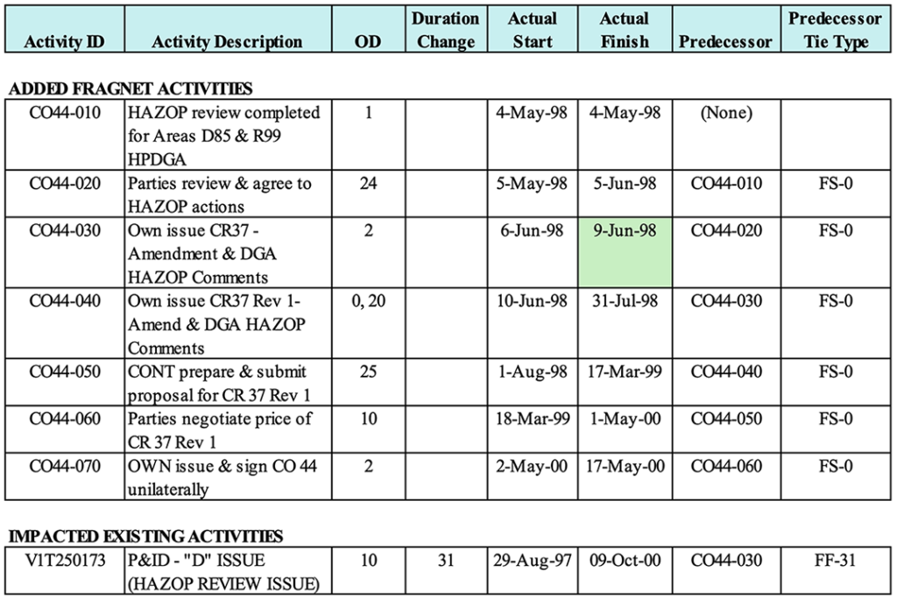
The above data relates to Change Order No. CO44 and the fragnet chain of activities spans the time frame from May 4, 1998, when the HAZOP review was completed, through May 17, 2000, when the change order was unilaterally issued by the Owner. The cell highlighted in green relates to the Contractor’s actual start date of the change order work.
The June 9, 1998 date highlighted for fragnet activity CO44-030 was the date that the Contractor started work based upon receipt of the Owner’s Change Request No. 37, and it was found that the finish of the existing HAZOP schedule activity V1T250173 was affected by this particular change order. Further, it was estimated that Change Order No. CO44 would increase the original duration for the existing HAZOP schedule activity V1T250173 by 31 work days.
In addition, an FF 31 tie was inserted between the starting fragnet activity CO44-030 and the finish of the existing HAZOP schedule activity V1T250173. Figure 11 provides a graphical depiction of the logic and extended duration from the driving Change Order No. CO44 fragnet activities to the finish of the existing HAZOP schedule activity V1T250173.
Figure 11
Example Impact to Areas D85 & R99 P&IDs – Change Order No. CO44
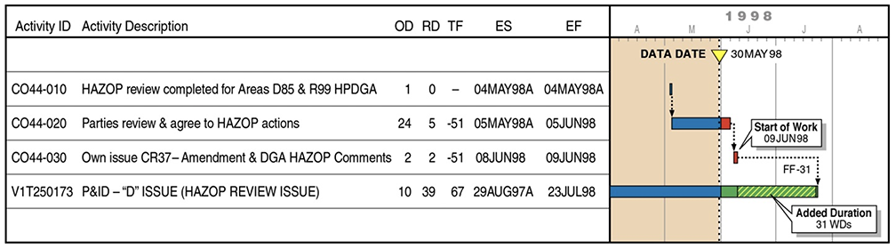
For Change Order No. CO44 and all other change orders that were analyzed, each change order fragnet was inserted into the first monthly schedule update that existed immediately prior to the start date of each fragnet and then in all successive updates to model monthly change order fragnet progress.
6.6 STEP 6 – GLOBAL VS. STEPPED INSERTION SEQUENCE
According to AACE® International’s Recommended Practice 29R-03,³³ change order fragnet delays can either be inserted using a Global Insertion sequence (all delays that occurred during the time period covered by a window are added at one time) or using a Stepped Insertion sequence, i.e., one delay added at a time into a schedule on a chronological basis. After all impacts are added on a Stepped Insertion basis to a given schedule update, the final result would be the same as in the case where all impacts are added on a Global Insertion basis. However, one advantage of using a Stepped Insertion basis for adding each impact chronologically into the schedule update is to determine the effect, if any, caused by each impact. Thus, if there are questions regarding the Contractor’s entitlement to a time extension for any given impact, it may be helpful to know the effect, if any, of that given impact on the results of the analysis.
Due to the substantial number of change order fragnet impacts that needed to be added to each analysis schedule, it was unpractical to use the Stepped Insertion sequence. Therefore, for the sample gas project, the Stepped Insertion method was not practical, and the more realistic approach was to utilize a Global Insertion sequence.
6.7 STEP 7 – EVALUATE CONTRACTOR-CAUSED DELAYS EMBEDDED IN OWNER-RESPONSIBLE EVENTS
As part of the evaluation of change order impacts that were inserted into the various analysis schedules, further evaluation of Contractor-caused delays embedded in Owner-responsible events was performed, especially for those impacts that spanned multiple months. For many of the change order fragnet impacts, several fragnet activities required the Contractor to provide information to the Owner that would allow for the change order scope to be finalized and a change order price to be accepted.
For example, the Contractor was responsible to provide timely input that was needed to complete change order scope definition and clarification. Also, the Contractor was responsible to provide the Owner with timely pricing of change orders, including the required supporting change order backup documentation as required by Contract. For many change orders, the Contractor did not provide the Owner with the needed information for change orders to be fully scoped, priced, and negotiated in a timely manner. These Contractor-caused delays were identified, quantified, and excluded from the TIA/UIA that was used to determine the Contractor’s entitlement to a time extension.
6.8 STEP 8 – CALCULATE AND SUMMARIZE RESULTS
The sum of the delay results for the change order fragnet and duration delays, as calculated in each schedule analysis window, represents the Contractor’s entitlement for an overall time extension from the Owner. After adding the delays to the overall schedule completion date caused by change orders, the time extension in the schedule completion date is the amount of time extension that the Contractor is entitled to receive before the Owner’s entitlement to liquidated or actual delay damages as a result of other Contractor-caused delays can properly be assessed. Conceptually, the results of the TIA/UIA are shown in Figure 12 below:
Figure 12
Results from the TIA/UIA by Analysis Window
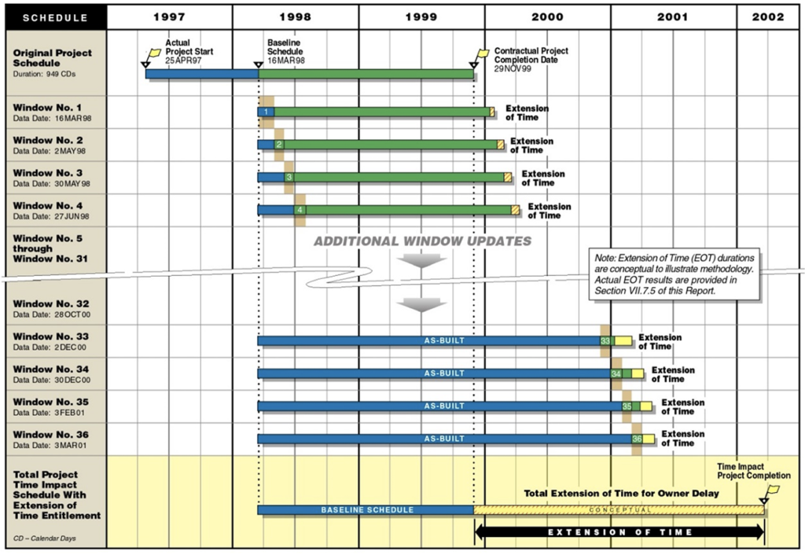
The results of the TIA/UIA can be further summarized to show a summary bar for the baseline schedule or contract schedule, a summary bar for the results of the TIA with change orders or Owner-caused delays, and a summary bar for the as-built schedule showing the actual project completion and potential Contractor-caused delay.
Contractor-caused delays could extend beyond the project completion date that is determined from the TIA/UIA. Figure 13 provides a graphical description of how an Owner’s entitlement to delay damages is determined if the actual project completion is later than the impacted project completion date after considering a Contractor’s entitlement to a time extension as a result of Owner-caused delays such as change orders.
Figure 13
Summary Results from the Detailed TIA/UIA
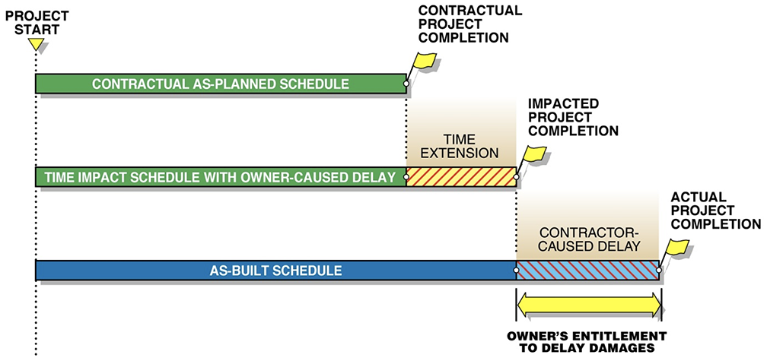
As depicted above, change orders caused delay as determined by the TIA/UIA, and the Contractor should be entitled to receive an extension of time for the change order impacts. However, as shown in Figure 13, the actual project completion can be later in time when compared to the project completion date that is determined by the TIA/UIA. This additional delay could provide the Owner with entitlement to liquidated or actual delay damages.
7. SUMMARY
Performing a detailed Time Impact Analysis on large and complex projects, which are often highly impacted and disrupted, can be challenging. An assessment on the limitations on available project data and information that would support a detailed TIA/UIA should be given a high priority before starting a TIA/UIA or any schedule analysis. The most common type of impact format is an added fragnet activity or group fragnet, but other forms of impact formats can include adjustments to existing activity durations, start delays to successor activities, or a combination of all of the above.
For highly impacted and disrupted projects, a recommended schedule impact analysis methodology using the TIA/UIA to evaluate delay due to approved change orders includes the following general steps: 1) create fragnets for change orders, 2) consider the blindsight approach for fragnets that span multiple months or analysis periods, 3) assess start of work impacts, 4) estimate duration impacts on existing schedule activities, 5) determine the use of finish-to-finish logic and lag values, 6) consider global change order delay insertion sequence, 7) evaluate Contractor-caused delays embedded in Owner-responsible events, and 8) calculate and summarize results. Throughout the process, it is highly recommended that all notations, assumptions, and variations be recorded for traceability and future reference.

